* Constitution of Almendria -

## In the name of the Glorious Almendrian People, the first Article will hereby be Article One, pertaining to the essential identity of the Nation

S1: Almendria is hereby united to one, named forever the National State of Almendria, or Communist Union of Almendria.

S2: The flag of Almendria shall be the foremost National Symbol, and it shall be this Flag

S3: The Coat of Arms of the Almendrian People shall hereby be the second most important National Symbol, and shall be the following.



S4: The Seal of the Almendrians shall the the third most important national symbol, and shall be the following  


S5: The Alternative Flag of the Almendrian Armed Forces shall be fourth most important symbol of the Almendrian people, and also be the single military flag for all branches.  


S6: The Nation of Almendria is based on socialist traditions

## In the name of the Glorious Almendrian People, the Second Article will hereby be Article Two, pertaining to the minor identity of the Nation, Amendments, and Socialism.

S1: The Almendrian constitution is unamendable, with only temporal dispositions being allowed. No article may be removed from this Constitution.

S2: Map of the grand territory of Almendria

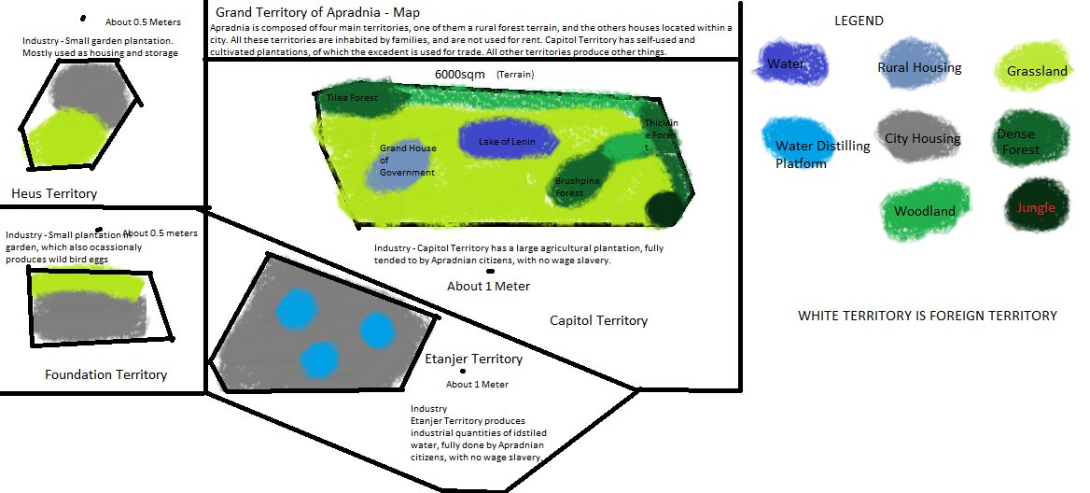

S3: Socialism is defined as “A society where workers own the means of production”

S4: Perfect Socialism is defined as “A society without currency, where workers own the means of production, distribution and exchange”

S5: Communism is defined as “A stateless society without currency, where workers own the means of productions, governance, distribution, and exchange.

S6: The State of Almendria, is owned by the workers through the Almendrian Party and through the Executive and Legislative powers, therefore, Socialism may be achieved.

S7: Worker ownership of the means of production includes the workers having the full fruits of their labour. It also includes workers having full control of where they work, potentially through Worker’s Soviets.

S8: Taxes on Almendrian citizens are forevermore outlawed on Almendria and it’s territory.

S9: The Government is to aspire for Perfect Socialism.

S10: All who desecrate Almendrian national symbols, authorities, or government, or this constitution, after a unanimous 1hour shortvote by the Red Congress, are considered subhumans and may be treated as needed for the security of Almendria. This must be confirmed by 3 Supreme Judges

S11: All willing humans may be Almendrian citizens, as long as they swear an Oath of Loyalty.

S12: Almendrian citizenship may only be stripped under articles of this Constitution, or by direct order of a President, General President, Marshal, Supreme Marshal, General Secretary, Sovereign Vote of the National Assembly, or a 51% majority in the Red Congress.

## In the name of the Glorious Almendrian People, the Third Article will hereby be Article Three, pertaining to the rights, obligations and freedoms of Almendrian citizens, as well as Martial Law.

Martial Law

S1: **No rights may be removed, or modified, or added. All rights may only be removed by the establishment of Level 10/X Martial Law.**

S2: The lowest type of martial law is Level One Martial Law, which does not allow for suspension of rights, and only for the utilization of the military within national territory. Level One martial law is automatically declared if war has been declared, or by decision of a President, General President, or by majority vote of the Red Congress or National Assembly.

S3: Level Five Martial Law suspends most of the rights for anyone over 14 years old, along with allowing everything which Level One does. It may only be declared by a 60% in favour result, on a vote of the National Assembly. This suspends all rights but that to bear arms and equaity before the law.

S4: Level Ten Martial Law suspends all rights within the Constitution, along with suspending the Constitution itself, leaving the National Assembly as completely sovereign and not binded by this Constitution. The General President’s title is to be changed to Dictator during this time, all civilian government is to be disabled, the Supreme Marshal may utilize power of life, death and Imperium. This allows the Dictator or Supreme Marshall to pass a Martial Estatute, which has the same Imperium as the constitution, with only the National Assembly being allowed to repeal it. This Martial Law may only be declared with a 80% in favour vote of the National Assembly, confirmation by General President and all presidents, Marshals, Supreme Marshal, and a unanimous Red Congress confirmation.

S5: X-Level is an addition to Martial Law and allows the disabling of Imperium of the National Assembly. This level repeals National Assembly sovereignty. All power of the National Assembly may go to the General President/Dictator during this period. X-Level may only be disabled by the General President/Dictator. This may only be enabled during Level 10 Martial Law, by 90% vote of the National Assembly, or by Military Unanimous Resolution.

S6: N-Level allows the use of Weapons of Mass Destruction freely, at the discretion of the Supreme Marshall or General President. This may only be enabled by Military Unanimous Resolution.

Rights, Freedoms and Obligations.

S1: All persons shall be equal before the law. All persons shall have the right to equal treatment by public authorities.

S2: No one shall be discriminated against in political, social or economic life for any reason whatsoever.

S3: Men and women shall have equal rights in political and economic life. Men and women shall have equal rights, in particular, regarding education, employment and promotion, and shall have the right to equal compensation for work of similar value, to social security, to hold offices, and to receive public honors and decorations. This also forbids discrimination of men in favour of women.

S4: All non-citizens may become citizens by filling out the citizenship form.

S5: All citizens have the right to freedom of the press, freedom of opinion, and freedom of speech

S6: A census may be held every 10 years, at least.

S7: Each citizen has the right to vote by age of 13

S8: Citizens gain the right to form and join political subparties at the age of 13

S9: Each citizen can run for office by age of 13

S10: Each citizen can be employed by non-governmental/governmentall offices and employers by age of 10 with the consent of the guardians, and by age of 13 with only the consent of the person.

S11: All Students are to be considered equal to workers in Socialism.

S12: The people’s rights to own and bear arms, **shall not be infringed, or regulated, in any way.** All citizens who own arms are obligated to be soldiers in the case a war breaks out, but may remain as civilians otherwise.

S13: **All citizens are obligated to revolt if the government dares attempt to desecrate Socialism, or to desecrate this Constitution. *Not doing so is to be punished by death.***

## In the name of the Glorious Almendrian People, the fourth Article will hereby be Article Four, pertaining to the legislative power.

S1: To join the Red Congress, you must be an Almendrian citizen and at least thirteen years of age.

S2: There is a maximum of one congressmen per 30 Almendrian Citizens.

S3: The member of congress term lasts 3 years for Resident Congressmen, and 1 week for Non-Resident Congressmen.

S4: The Red Congress are elected by  
 - The General President, with 10 votes.

* The Presidents, with 5 votes each.
* The Vice Presidents, with 3 votes each.
* The Supreme Marshal, with 3 votes.
* The Generals, with 2 votes each.
* The AR-Leaders, with one vote each..
* The Ministers, with half a vote.
* All Subsecretaries, secretaries, etc have a collective vote and an individual advisory vote.
* Current Red Congressmen have an advisory vote each.
* All citizens may present a collective advisory vote.

S5: The General President, or a President, may choose to deliver Red Congress vote to public (National Assembly) elections. These elections may be vetoed, overruled, or cancelled, but not rigged.

S6: The Red Congress may present priority Resolutions to the National Assembly. These must be voted first, and only require a majority (not 51%).

S7: The Red Congress may veto National Assembly resolutions, with a 51% vote.

S8: The General President may execute Vetorum Dictatus, and veto a National Assembly resolution.

S9: The General President may unilaterally pass resolutions as long as agreed to by at least 50% of Presidents. Otherwise, he may pass decrees, which have the same power but can be repealed by a Red Congress majority.

S10: The General President, with the approval of at least one president, may unilaterally declare Supremacia, which grants him sovereignty like that of the National Assembly.

S11: The National Assembly is a sovereign supreme legislative power.

S12: The National Assembly is composed of all citizens.

S13: The National Assembly may pass any non-priority Resolutions with a 51% yay vote.

S14: The National Assembly may not depose the General President unless by unanimous vote.

S15: The National Assembly is bound only by this Constitution, and may not remove any articles of it.

S16: The General President, Presidents, Vice Presidents and Grand Ministers. form the Executive Council. The Supreme Marshal is also a member.

S17: The Ministers, Trial Ministers, Secretaries and Subsecretaries, form the Ministerial Council.

S18: All officers of the National People’s Red Almendrian Military are members of the Centuriate Council.

S19: All soldiers are part of the Centuriate Assembly, which has equivalent powers to the National Assembly, but is not sovereign.

S20: The Centuriate Assemblie’s resolution may be treated as Decrees, not as National Assembly Resolutions.

S21: The Speaker of the Red Congress represents the Red Congress to the Executive Council, and is the highest voted party.

## In the name of the Glorious Almendrian People, the fifth Article will hereby be Article Five, pertaining to the Executive power.

S1: The General President is the supreme, semi-sovereign head of State and Government of the Nation, who rules the whole of Almendria. The General President also has the title of Supreme Marshal of the Military, which is the only title above Supreme Marshal.

S2: The Presidents are the heads of government, who help the General President and manage day to day running of the State.

S3: The Position of General President is inherited. Only sons or daughters of the last General President may take the position.

S4: The General President may abdicate towards anyone, in which case that anyone will become General President, instead of his direct descendant.

S5: The Presidents are appointed

* By the General President, unilaterally.
* By the Red Congress, with a 80% majority.
* By the Autonomous Republics, with a 60% majority on the Federal Council.
* By the National Assembly, with a simple majority.

S6: The Presidents may be removed

* By the General President, unilaterally.
* By the Executive Council, with a 60% majority.
* By the Archbishop of Almendria
* By the National Assembly, with a simple majority.
* By the Red Congress, with an 80% majority.
* By the Minister of Intelligence, unilaterally.
* By the Supreme Marshal, unilaterally.

S7: The Supreme Marshal is the supreme head of the Almendrian combined armed forces. Only the General President overranks him on the Almendrian Armed Forces.

S8: The Supreme Marshal may be appointed by the General President unilaterally, or in his absence, by a 60% Red Congress or Executive Council majority.

S9: The Supreme Marshal may only be removed by the General President, or whoever is in control if he is absent.

S10: The Archbishop of Almendria is the supreme religious authority of Almendria.

S11: If there is no Supreme Marshal or General President, the Archbishop of Almendria shall take the position.

S12: The Church of Almendria is a non-denominational Christian church.

S13: The Archbishop of Almendria must be male.

S14: The Archbishop of Almendria is considered to be the Vicar of Christ and leads in His absence His church.

S15: The Archbishop of Almendria may not be enganged on any sexual sin. The Archbishop of Almendria must have a net worth below 500.000$ USD 2022.

S16: The Archbishop of Almendria may unilaterally declare Apocalipsis, which inmediately puts into place Level 10 Martial Law with both X and N level enabled. He shall only do this if Christ returns or will return during the next ten years. This is to be done to protect the Almendrian people from the Antichrist, and automatically deposes the Archbishop, allowing none to take his position for at least 20 years.

S17: Vice-Presidents are helpers to the Presidents. They have no official duties. They may promote Grand Ministers. Only the President may appoint up to 2 Vice-Presidents to rule on his stead. Each president may appoint 2 as a maximum.

S18: Grand Ministers are ministers who have a important duty and who worked for the position. They may be appointed by a Vice-President, President, or General President.  
  
In the name of the Glorious Almendrian People, the fifth Article will hereby be Article Five, pertaining to the Judicial power.

S1: The Judicial power shall be head by a Supreme Justice, who is to be chosen by the National Council.

S2: The General President is also Trial Supervisor on all trials, and may veto or declare the person guilty on any trial except those regarding himself.

S3: The General President’s veto may be overruled by the National Council, unless Supremacia is declared.

S4: The National Council is made up of 7 Justices.

S5: The National Council is in charge of all trials, and the Justices may delegate however they wish.

S6: Justices may not be removed, at any time, for any reason.

S7: The High Court is made out of 3 Justices, and may remove National Council justices, only with a unanimous vote, approval from the General President and Supreme Marshal, and with the only reason being corruption.

S8: High Court justices are chosen at random from National Council justices.

S9: Anyone has the right to a fair trial by jury and judge if they want it.

S10: The National Council is the default jury, but they may delegate.  
  
In the name of the Glorious Almendrian People, the sixth Article will hereby be Article Five, pertaining to the Autonomous Republics.

S1: Autonomous Republics shall be ruled by the treaties signed with each Autonomous Republic.

S2: Leaders of Autonomous Republics form the Federal Council.

S3: Autonomous Republic’s embassies to Almendria and from Almendria shall be known as Consulates.

In the name of the Glorious Almendrian People, the sixth Article will hereby be Article Five, pertaining to this Constitution.

S1: This Constitution may not be amended, at any time, for any reason.

S2: No Article may be removed from this Constitution, except by reasons outlined on it.

S3: This Constitution maintains Supreme Imperium at all times, which cannot be revoked, over all Almendrian territory and people.

SIGNATURES

*Tizian Aruna, Founder of Almendria*

*Kazzi, Die Leider of the Almendrian Natuonal State*